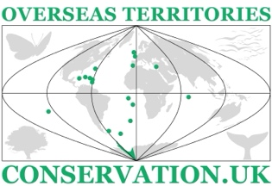  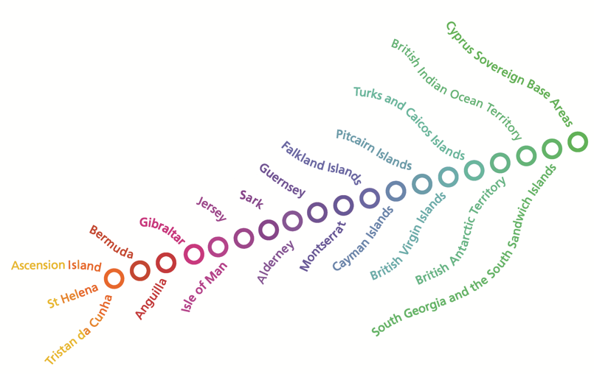 | UKOTCF’s 7th conference on conservation and sustainability in UK Overseas Territories, Crown Dependencies and other small island states  By Zoom  13th to 16th October 2025

Offers of talks and posters

Please fill out the following information and return to m@pienkowski.org and cwensink@ukotcf.org

I would like to offer (please delete as appropriate)

A talk

A poster

Name(s) of author(s), with institution(s) if appropriate;

Contact details for presenting author;

Territory/ies, if appropriate
Conference topic(s) that the talk could fit within
Title of talk/poster
Abstract of talk/poster
Any suggestions for conference conclusions or recommendations related to this topic and talk/poster
Please agree to supply the material noted in the timetable by the deadlines indicated, and recognition that failure to do this may mean any invitation to speak being withdrawn | Yes/No
If space is not available for the presentation as a talk, the authors wish to offer this as a poster. | Yes/No

Please save the form with your name and return to m@pienkowski.org and cwensink@ukotcf.org

